**HOW TO PUSH YOUR CLASSWORK PROJECTS INTO GITHUB**

At the end of the day, you should have already created a folder on the desktop (or wherever) named W#{week}D#{day} where you created and saved your classwork projects files.

If you have not, do so now before proceeding… and make sure you save your files once again in case you may have missed one.

Once you have your folder (with your files ready), go into your GitHub account and create a new repo by clicking the “New Repository” green button.

Under the “Repository name” enter the name of your folder “W2D2”. You can obviously give it another name or a more extended name. I usually include the names of the various projects and classwork to identify them easily. Here’s an example: “W2D2 Chess”.

You may include an optional description, under the “Description” box.

Once done, click the green “Create repository” button. This will take you to the following page:

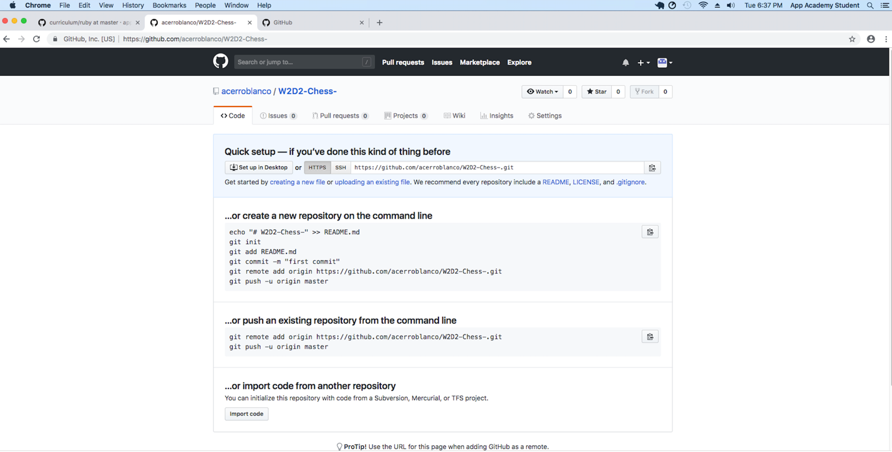

Next, click on the on the clipboard icon to the right of the URL under “Quick setup – if you’ve done this kind of thing before”. This will automatically copy the URL on the left of the icon. You’re going to need this later when you push into your new GitHub repo.

Next, go into the terminal and cd into your folder (where you saved your classwork project files). For me, this would be “W2D2 Chess” for today.

Once there, type “git init.” (You may “ls” if you want to see if your files are there, that way you may double check you are in the correct folder or directory).

Optionally, you may type in “git status” to see if what files are untracked or added or committed. It is recommend that you “git status” regularly to avoid making mistakes.

Next, type in “git add .” The period at the end tells the git in the terminal to ‘stage’ all the files in the folder or directory.

Type “git status” again to see that are your files have turned green, indicating that each has been ‘staged’.

Next, type “git commit -m ” and type a short message like “Created W2D2 Chess”.

Do, git status again. You should see the following in the terminal:

On branch master

nothing to commit, working tree clean

This means that your commits were successful and are now ready to be pushed, if desired.

Before pushing, type “gca”, a space, your GitHub Username, space and your email you use for GitHub. This is a bash scripted created by your instructors ensure that your GitHub username & email are written as the ‘author’ of your commits. Otherwise, a non-name generic identify will be used and your instructors will not be able to find you.

Next, type in ‘git log’ to see a record of your recent commits.

Do “git status” again and you should get the same message as the last time you requested your status.

Next, type paste in (or type, if you prefer) in the terminal the following:

~/desktop/W2D2_Chess (master)$ git remote add origin <https://github.com/acerroblanco/W2D2-Chess-.git>

~/desktop/W2D2_Chess (master)$ git push -u origin master

This will push your commits into your GitHub repo you just created for your new classwork project for that day. But before it’ll work, you be prompted in the terminal will prompt for your GitHub username and password. Once your done, you’re new commits have been pushed.

You may do “git status” again, if you like.

Also, if you would like to change your ‘remote’, before pushing into your repo, do the following in the terminal:

Type in “git remove add”, add a space, type in the name of your new remote, add another space and add the GitHub repo’s URL.

Type in “git remote” to see if your new name for your remote was added.

To push, type in “git push”, add a space, name of new remote, and type in “master”.

~/Desktop/W2D2_Projects/chess (master)$ pwd

/Users/appacademy/Desktop/W2D2_Projects/chess

~/Desktop/W2D2_Projects/chess (master)$ cd

~$ pwd

/Users/appacademy

~$ ls

4.2.0 Desktop Downloads Movies Pictures Sites

Applications Documents Library Music Public w1d3

~$ cd desktop

~/desktop$ ls

Screwdoku W1D5 W2D2_Chess.zip

W1D1 W2D1 appacademy-online-tic-tac-toe-3a188953726e

W1D1.zip W2D2 colorize-master.zip

W1D3 W2D2_Chess tree-view.atloc

W1D3.zip W2D2_Chess 2.zip

W1D4 W2D2_Chess 3.zip

~/desktop$ cd W2D2_Chess

~/desktop/W2D2_Chess (master)$ ls

Chess

~/desktop/W2D2_Chess (master)$ git status

On branch master

No commits yet

Changes to be committed:

  (use "git rm --cached <file>..." to unstage)

new file:   .DS_Store

new file:   Chess/.DS_Store

new file:   Chess/board.rb

new file:   Chess/colorize-master/.gitignore

new file:   Chess/colorize-master/.hound.yml

new file:   Chess/colorize-master/.rubocop.yml

new file:   Chess/colorize-master/.travis.yml

new file:   Chess/colorize-master/CHANGELOG

new file:   Chess/colorize-master/Gemfile

new file:   Chess/colorize-master/LICENSE

new file:   Chess/colorize-master/README.md

new file:   Chess/colorize-master/Rakefile

new file:   Chess/colorize-master/colorize.gemspec

new file:   Chess/colorize-master/lib/colorize.rb

new file:   Chess/colorize-master/lib/colorize/class_methods.rb

new file:   Chess/colorize-master/lib/colorize/instance_methods.rb

new file:   Chess/colorize-master/lib/colorized_string.rb

new file:   Chess/colorize-master/test/test_colorize.rb

new file:   Chess/colorize-master/test/test_colorized_string.rb

new file:   Chess/cursor.rb

new file:   Chess/display.rb

new file:   Chess/pieces.rb

Changes not staged for commit:

  (use "git add <file>..." to update what will be committed)

  (use "git checkout -- <file>..." to discard changes in working directory)

modified:   .DS_Store

modified:   Chess/cursor.rb

modified:   Chess/display.rb

modified:   Chess/pieces.rb

~/desktop/W2D2_Chess (master)$ git add .

~/desktop/W2D2_Chess (master)$ git commit -m "Update W2D2 chess project"

[master (root-commit) e319eaa] Update W2D2 chess project

 22 files changed, 2639 insertions(+)

 create mode 100644 .DS_Store

 create mode 100644 Chess/.DS_Store

 create mode 100755 Chess/board.rb

 create mode 100755 Chess/colorize-master/.gitignore

 create mode 100755 Chess/colorize-master/.hound.yml

 create mode 100755 Chess/colorize-master/.rubocop.yml

 create mode 100755 Chess/colorize-master/.travis.yml

 create mode 100755 Chess/colorize-master/CHANGELOG

 create mode 100755 Chess/colorize-master/Gemfile

 create mode 100755 Chess/colorize-master/LICENSE

 create mode 100755 Chess/colorize-master/README.md

 create mode 100755 Chess/colorize-master/Rakefile

 create mode 100755 Chess/colorize-master/colorize.gemspec

 create mode 100755 Chess/colorize-master/lib/colorize.rb

 create mode 100755 Chess/colorize-master/lib/colorize/class_methods.rb

 create mode 100755 Chess/colorize-master/lib/colorize/instance_methods.rb

 create mode 100755 Chess/colorize-master/lib/colorized_string.rb

 create mode 100755 Chess/colorize-master/test/test_colorize.rb

 create mode 100755 Chess/colorize-master/test/test_colorized_string.rb

 create mode 100644 Chess/cursor.rb

 create mode 100644 Chess/display.rb

 create mode 100755 Chess/pieces.rb

~/desktop/W2D2_Chess (master)$ git status

On branch master

nothing to commit, working tree clean

~/desktop/W2D2_Chess (master)$ git log

commit e319eaaa3e6eba85463a46a8bf343ca5fdaf3dac (HEAD -> master)

Author: ericswetts <[eric.swetts@gmail.com](mailto:eric.swetts@gmail.com)>

Date:   Tue Oct 30 18:23:13 2018 -0700

    Update W2D2 chess project

~/desktop/W2D2_Chess (master)$ gca "accerroblanco" "[acerroblanco@gmail.com](mailto:acerroblanco@gmail.com)" "acerroblanco" "[acerroblanco@gmail.com](mailto:acerroblanco@gmail.com)"

Rewrite e319eaaa3e6eba85463a46a8bf343ca5fdaf3dac (1/1) (0 seconds passed, remaining 0 predicted)

Ref 'refs/heads/master' was rewritten

~/desktop/W2D2_Chess (master)$ git status

On branch master

nothing to commit, working tree clean

~/desktop/W2D2_Chess (master)$ git log

commit 2b80343c6cd1e2a0ae4120e31bcea79e2392105a (HEAD -> master)

Author: accerroblanco <[acerroblanco@gmail.com](mailto:acerroblanco@gmail.com)>

Date:   Tue Oct 30 18:23:13 2018 -0700

    Update W2D2 chess project

~/desktop/W2D2_Chess (master)$ gca "accerroblanco" "[acerroblanco@gmail.com](mailto:acerroblanco@gmail.com)" "acerroblanco" "[acerroblanco@gmail.com](mailto:acerroblanco@gmail.com)"

Rewrite 2b80343c6cd1e2a0ae4120e31bcea79e2392105a (1/1) (0 seconds passed, remaining 0 predicted)

WARNING: Ref 'refs/heads/master' is unchanged

~/desktop/W2D2_Chess (master)$ gca "acerroblanco" "[acerroblanco@gmail.com](mailto:acerroblanco@gmail.com)" "acerroblanco" "[acerroblanco@gmail.com](mailto:acerroblanco@gmail.com)"

Rewrite 2b80343c6cd1e2a0ae4120e31bcea79e2392105a (1/1) (0 seconds passed, remaining 0 predicted)

Ref 'refs/heads/master' was rewritten

~/desktop/W2D2_Chess (master)$ git log

commit 366a56920b9c88f715c55785f999915b01f0e767 (HEAD -> master)

Author: acerroblanco <[acerroblanco@gmail.com](mailto:acerroblanco@gmail.com)>

Date:   Tue Oct 30 18:23:13 2018 -0700

    Update W2D2 chess project

~/desktop/W2D2_Chess (master)$ git remote add origin <https://github.com/acerroblanco/W2D2-Chess-.git>

~/desktop/W2D2_Chess (master)$ git push -u origin master

Username for '<https://github.com/acerroblanco/W2D2-Chess-.git>': acerroblanco

Password for '<https://acerroblanco@github.com/acerroblanco/W2D2-Chess-.git>':

Counting objects: 29, done.

Delta compression using up to 4 threads.

Compressing objects: 100% (26/26), done.

Writing objects: 100% (29/29), 24.60 KiB | 3.08 MiB/s, done.

Total 29 (delta 3), reused 0 (delta 0)

remote: Resolving deltas: 100% (3/3), done.

remote:

remote: Create a pull request for 'master' on GitHub by visiting:

remote:      <https://github.com/acerroblanco/W2D2-Chess-/pull/new/master>

remote:

To <https://github.com/acerroblanco/W2D2-Chess-.git>

 * [new branch]      master -> master

Branch 'master' set up to track remote branch 'master' from 'origin'.

~/desktop/W2D2_Chess (master)$ git status

On branch master

Your branch is up to date with 'origin/master'.

nothing to commit, working tree clean

~/desktop/W2D2_Chess (master)$ git log

commit 366a56920b9c88f715c55785f999915b01f0e767 (HEAD -> master, origin/master)

Author: acerroblanco <[acerroblanco@gmail.com](mailto:acerroblanco@gmail.com)>

Date:   Tue Oct 30 18:23:13 2018 -0700

    Update W2D2 chess project

~/desktop/W2D2_Chess (master)$